1.1 Export Solutions 1

1.2 Import Solutions 1

1.3 Migrate Solutions 1

To use any of these features defined above click Solution Import / Export on the main menu and select the appropriate Import Export Task Type in the form

Note apart from Import Solutions these features use the Saved XRM Connections which are configurable in the Settings menu to allow selection of and connect to CRM instances

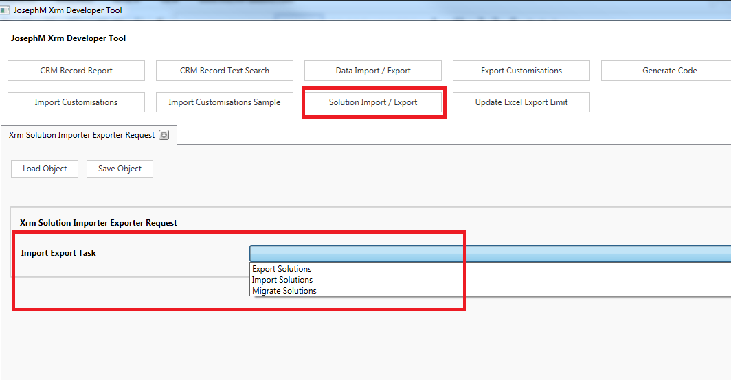

## Export Solutions

This feature is designed simply to allow exporting solutions from one or more CRM instances in managed or unmanaged states

For each solution to export add a row to the Solution Exports grid, select the connection (the connection must be a saved as a Saved XRM Connection), then select the solution to export in the solution dropdown

Additionally data may be included in the export be clicking to edit the row and adding to the Data To Export grid in the Solution Export edit form

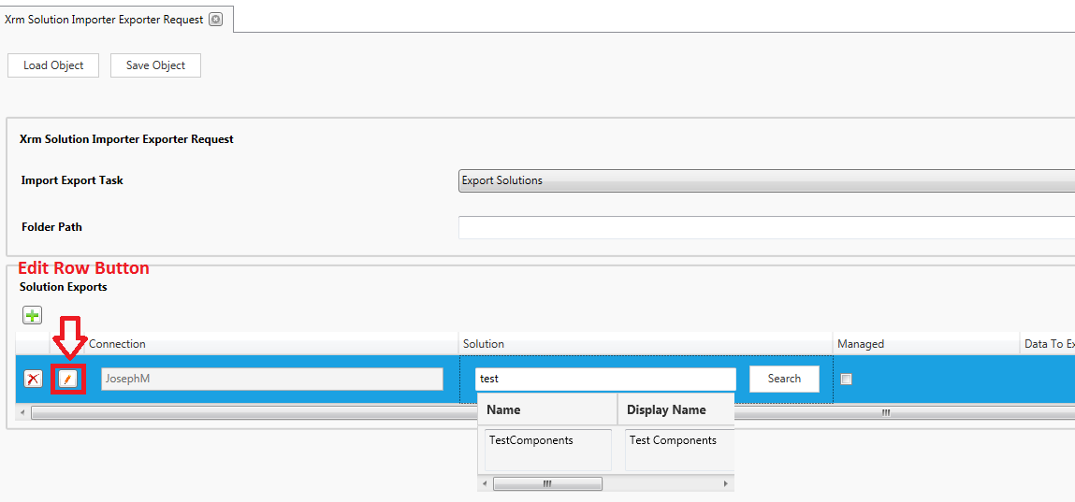

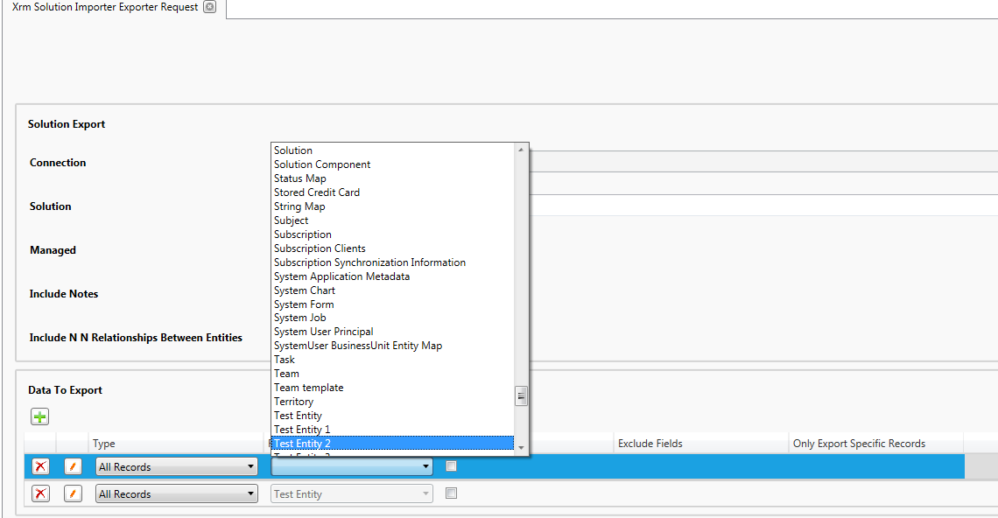

## Import Solutions

This feature is designed simply for importing and publishing one or more CRM solutions into a CRM instance

Select the solutions to Import by adding to the Solutions To Import Grid and selecting the solution files. Optional ordering allows specifying an order for the import where there are dependencies between solutions

## Migrate Solutions

This feature is designed for migrating solutions from source to target environments as well as optionally including data

Note environments must be saved as a Saved XRM Connection to be selected as one the migration sources or the target

To add a source solution add a row to the Solution Migrations grid, select the connection, then select the solution

To add data to the solution migration click to edit the Solution Migration row and add to the Data To Export grid

